Bill Sevesi

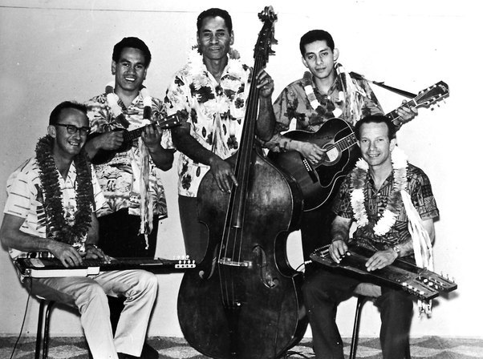

28th July 1923- 23rd April 2016

Musician and songwriter

