Scientist of the Week

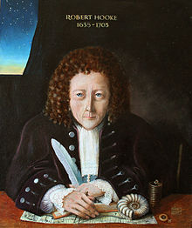
Robert Hooke
1635-1703

