Emmeline Pankhurst

Emmeline Pankhurst was a British political activist and leader of the British suffragette movement who helped women win the right to vote.

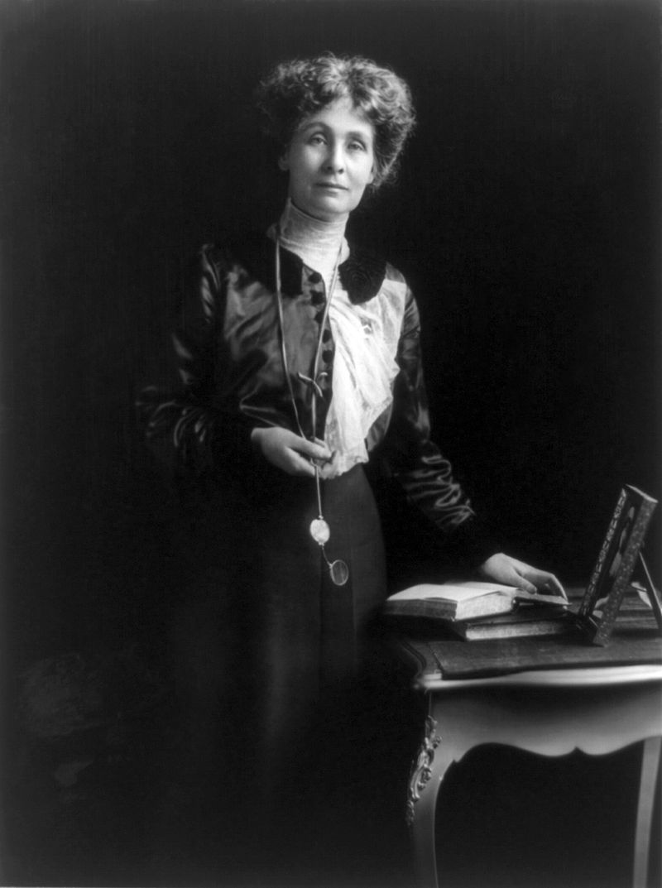

15th July 1858-14th June 1928

