Scientist of the Week

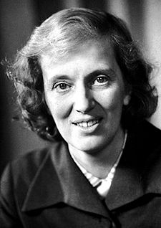
Dorothy Hodgkin
1910-1994

