Mathematician of the Week

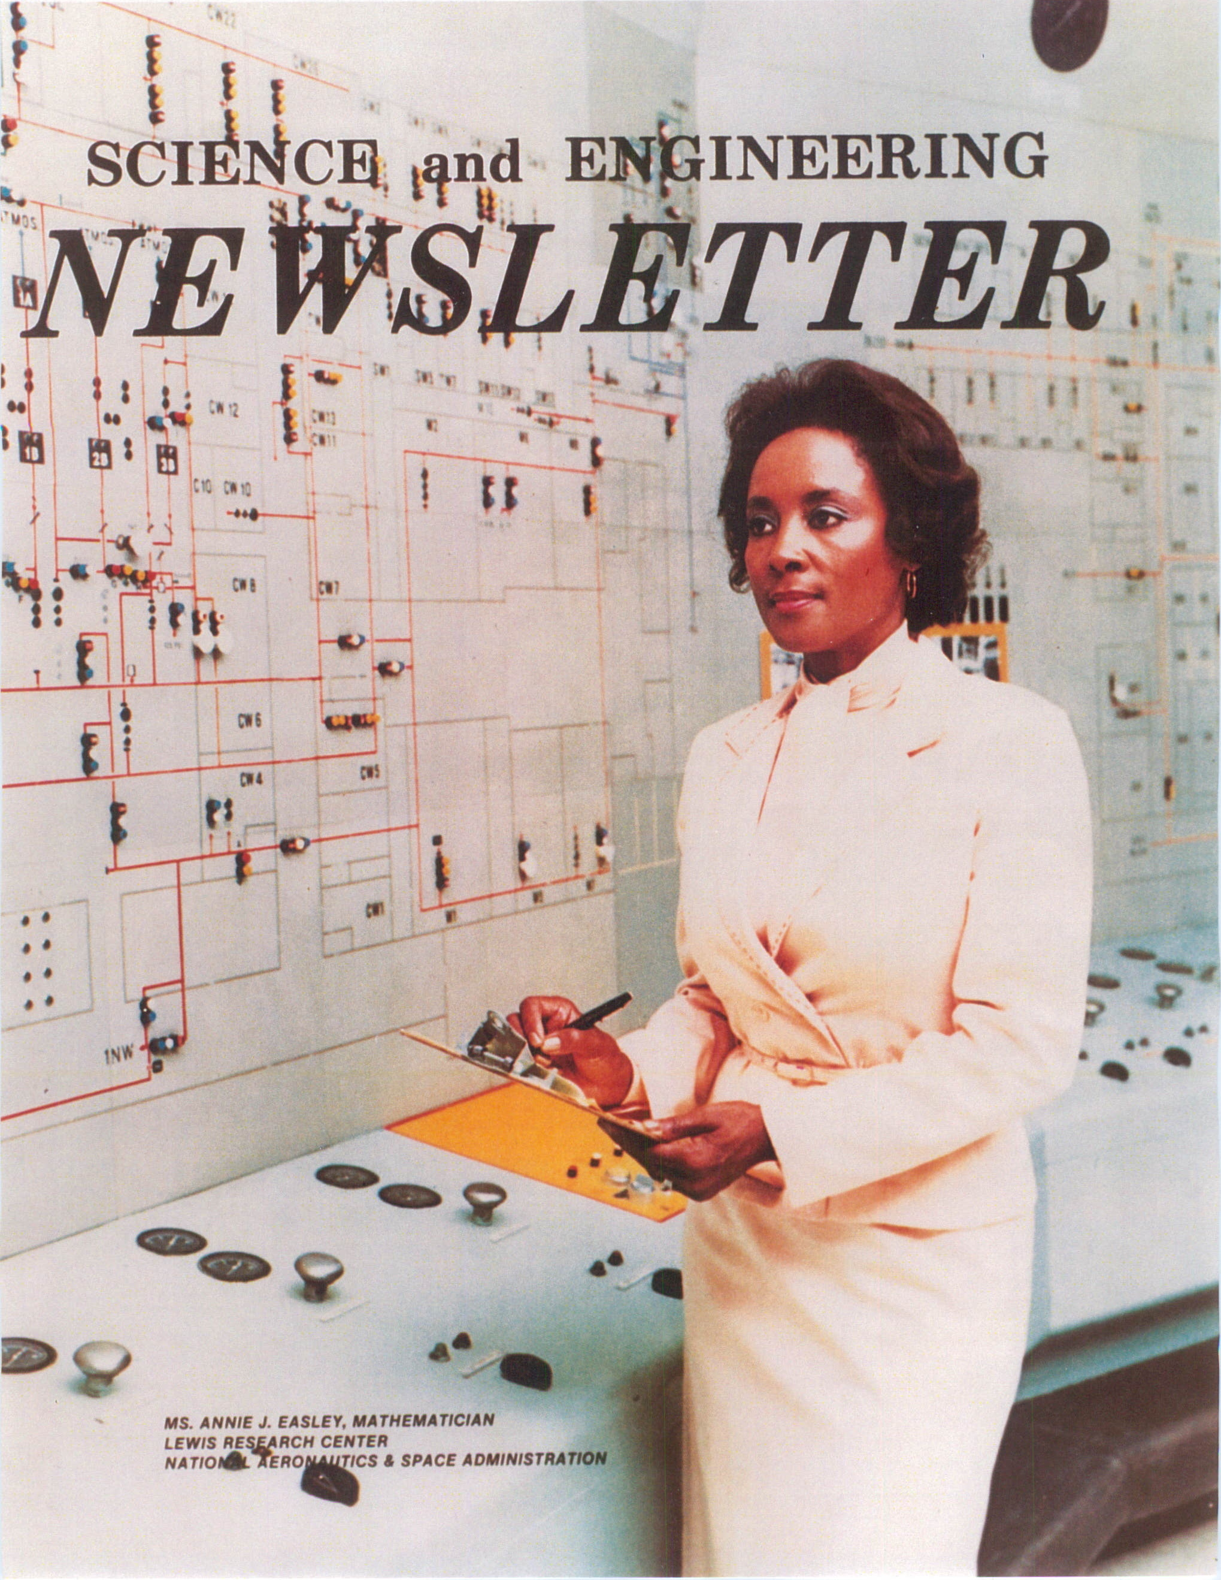
Annie Easley
1933-2011

